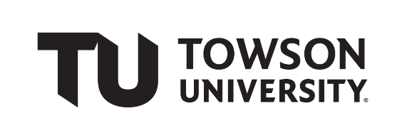

Team Working Agreement

# Team Name

|  |
| --- |
| **TEAM 10** |

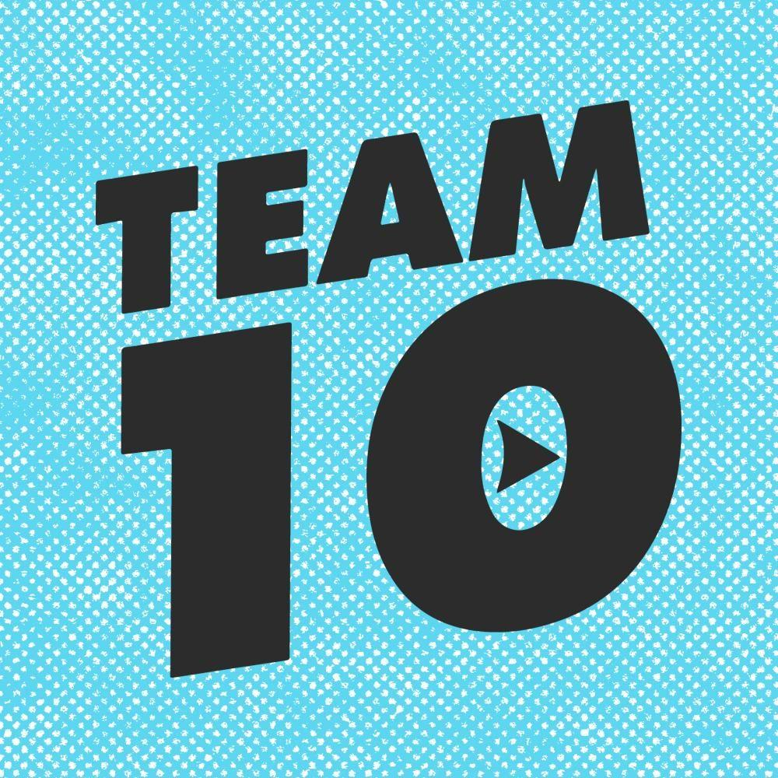Team Logo:

# Team Member Information and Roles

|  |  |  |
| --- | --- | --- |
| **Team Member Name** | **Role \*** | **Contact Info (e-mail & phone)**  **Preferred Method of Communication** |
| Krutik Dhiren Patel | Team Manager  Content Developer | Email: kpatel43@students.towson.edu |
| Logan Condron | Graphics Designer | Email: lcondr1@students.towson.edu |
| Antonise Smith | Technical Writer  Document Formatter | Email: asmith182@students.towson.edu |
| Taylor Chaney | Tester | Email: tchane2@students.towson.edu |

Contact Information Details:

In the above-authorized table, we only inputted email addresses for communication mediums because our group decided to utilize email as the primary means of communication.

Team Member's Information and Roles:

After discussing with our group about the course project, we decided to collaborate using email, which will be our preferred method of communication. In addition, each member's roles assigned above are subject to change as the project progresses because we decided that if someone needs more help on their part of the role, then others can share the responsibilities internally to ensure a smooth progressive transition.

# **Team Communication and Material-Sharing Strategies**

* For our group project, all our team members agreed upon utilizing blackboard group and discord as our primary means of communication. We chose discord and blackboard communication methods because these communication methods are already available to all our team members.
* Based upon each member’s course schedule, we decided that the best time to meet as a group would be on Mondays and Wednesdays in the afternoon, and Fridays, but this is subject to change.
* In addition, when reflecting upon where and how to meet, we decided to utilize technology, meaning we will meet via Zoom meeting (online) to discuss various requirements and the progress status of our project. But if someday one of our team members need additional help, then we also agreed upon meeting in person on campus as needed.
* All the documents, including reports, research papers, design papers, team contracts, and team role sheets, will all be securely stored using one-drive and GitHub. We chose these two mediums because our main goal is to store documents in a place where they can be accessible for all team members to refer to and edit if necessary. In addition, all the source code will also be encapsulated in OneDrive and GitHub for extended usability and efficiency.
* When reflecting upon project stage due dates, we will follow the dates assigned by the professor and project forum, meaning we will follow the standard due dates for each step of the project to ensure that we do not miss any due dates, and in fact, we would be able to complete and submit our work before the assigned date and time.
* In addition, if a particular team member is assigned to complete a report for the project, for example, if a member must complete a software usage manual, then before the time of the final submission, that report will be proofread (analyzed) by all the team members to ensure that there are no additional changes to make for improved corrections.
* When reflecting upon the assignment agreement, our group will follow the task assignment timeline, in which we detailed every piece of information about who does what assignment, and when they must complete it. In addition, this timeline is also subject to change because if one member finds a task difficult to accomplish, then members of the team can switch the assignments that they are assigned to ensure that each member is engaged and has a clear understanding of how to reach the finish line. In addition, when discussing assignment quality and content, every assignment will be reviewed and proofread by every member before the final submission because, with different perceptual analyses, the probability will get the transition in terms of creativity and unique insights. Therefore, another reason to proofread is to ensure that the document or application created by the assigned team member is easy to navigate and comprehend by others because it does not mean that if one member understands the document, the same will be predicted by others. Hence, these are ways in which we will assure assignment quality and completion.

# **Team Values, Behaviors, and Expectations**

* In many occupations in our industry, team grouping and work play a vital role because it helps to offer several various insights and flexibility. But when talking about the context of our course, software engineering is a dynamic process because when a team goes through the software development life cycle (SDLC), they must understand that the product being incorporated is not always guaranteed to function thoroughly due to the mistakes conducted either during the research process or in the implementational process. So, to adapt to this dynamic cycle of changes, a team must acquire a few principles to ensure a smooth transitional phase of every step of the project assigned. In addition, we believe that having principles in a team will always help to keep the team motivated and on the correct progress track because when many unique perspectives and experiences combine, it helps every group member to give their maximum effort, and alongside this will reduce difficulty level by sharing knowledge to help a team member achieve their task.
* Thus, the below listed are a few principles that will help guide our team through this course project:
  1. Creativity: In any project, the first phase of the design often initiates with a plan or an outline. So, during this requirement analysis phase, team members sit together to brainstorm ideas about their assigned project, such as what to build, how to build, and when to build. Hence, creativity is one of our guiding principles because this vital element will play a predominant role when we will being to brainstorm ideas about our application. Therefore, everyone must present their ideas freely without any hesitation because the more creative ideas we have on the table, the more opportunities we will have to improve our project goals and standards.

* 1. Conflict Resolution: During a group project, it is often that minimal conflict can arise in terms of fulfilling submission dates, completing the assigned task during the right time frame, and when someone is unfamiliar with a topic that they were assigned to fulfill. Thus, here the conflict resolution principle is crucial because as a team it is important to help each other always and resolve conflicts as soon as possible. After all, delaying them can lead to greater concerns. So, it is required for all to share responsibilities and resolve the uncompleted phase by providing valuable feedback or active participation.

* 1. Communication: To make a team successful, it is vital to incorporate a good communication system because it helps in terms of decision-making, meeting dates, and feedback analysis. Thus, communication will help to guide our team with transparency and fluency because not sharing at the right time can lead to multiple subjective aspects, meaning not every member will come to one table (or decision) during every step of our software development.

* 1. Engagement: Forming a team does not mean that the process will be completed on time, instead a team is incomplete without their full engagement and interest in the areas assigned. We mentioned engagement as a principle for our group having this element can help to increase the level of productivity and creativity because when individuals work on things they like and are passionate about, then it gets a bit easier to manage both time and assignment completions. In contrast, if members come to the group table with no interest and engagement, then it can get a bit difficult for the team to come up with innovations and lack feedback analysis.
* Team Expectations:
  1. Be on time: Time is a crucial part of being consistent with the project and submissions because being available at the time given is very important because, without that member’s collaboration, it can get a bit difficult to establish a completely redefined project.

* 1. Show Respect: All team members are required to show respect towards each other, and also towards the ideas and assignments that they bring to our group table. This fact is very important because respecting each other’s work and ideas will provide significant amounts of new insights into the topic given to developing. So, the more ideas come to the group table, the more room we can get to improve our project and application.

* 1. Bring problems to everyone as soon as possible: Discussion of problems is required to ensure smooth progress because not sharing difficulties can lead to future problems because then that member will not be able to complete their assigned part of the project. Thus, sharing progress and problems is necessary to ensure that members get their responses in a constructive time frame.

* 1. Ask questions and provide ideas: Freedom of expression, in terms of asking questions and bringing ideas to our group table is the most important factor when a group works on a project, it is not always necessary that every member acquires the same perspective on a given part of the software project. So, to resolve these minimal fixes, everyone is required by everyone to ask questions about the reports, research, or the source code for the software application to ensure that they have a clear understanding of what the project is about and why it is chosen to be accomplished. In addition, bringing new insights and ideas to our group table will help to improve our project measures because the more ideas are established, the more flexible the requirements can get in terms of project adaptation and acquirement.

* 1. Help every group member: Help is a vital factor to accomplish project goals because it is evident that not all team members acquire the same level of knowledge regarding software development and in terms of various known programming languages. For example, if one team member is fluent in C programming language development and others are good with the Java environment, then confusion can arise in terms of language structure and syntax encapsulation. So, here helping plays a very vital role because sharing knowledge will help others to gain new insights about the structures that they are unfamiliar with. Thus, having a helping nature is very important for our team to ensure knowledge transition.

# **Methods for Handling Team Issues**

* When an issue arises during any step or time, it is first required to share the details about that issue with all other team members via in-person or email if members are present at different locations during that specified time. Then, after acquiring all the details regarding the issue, each team member will analyze their areas of expertise to observe if the issue raised relates to their expertise area. If a member has experience regarding that topic, then they must be open to help resolve that issue. Meanwhile, other team members are also required to research how to resolve the issue as soon as possible to ensure a smooth transition. In addition, we will utilize the Zoom meeting application to discuss and resolve the issue if we are not present at the TU campus, and if all members are present during class, we can take a few minutes after class to brainstorm about techniques that will help to resolve or substitute that issue with another functional element.
* If a team member is not able to fulfill their responsibilities due to any reason, then according to the task timeline of other team members, the one with more additional time or area of expertise will be given the responsibility to complete the uncompleted task. In addition, the rest of the group must allocate a spare amount of time to contribute to help complete that task because when working in a team, completing tasks is not about one person, instead it is the responsibility of every member of the team.

# Approvals

Each member sign and date below

*We, the undersigned, agree to abide by the above document.*

|  |  |  |
| --- | --- | --- |
| **Name** | **Signature** | **Date** |
| Krutik Dhiren Patel | Krutik Dhiren Patel | 2/1/2023 |
| Logan Condron | Logan Condron | 2/2/2023 |
| Antonise Smith | Antonise Smith | 2/2/2023 |
| Taylor Chaney | Taylor Chaney | 2/2/2023 |